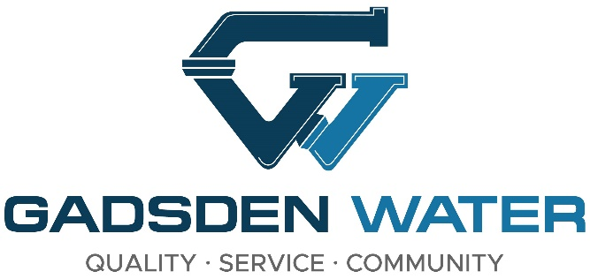
Maintenance Mechanic I

Gadsden Water is currently accepting applications for a Maintenance Mechanic I. Benefits include Local Government Blue Cross/Blue Shield Insurance, State of Alabama (Tier I) Retirement, paid time off and holidays. The current salary range for this position is $47,400 - $66,800. Must possess and maintain a valid Alabama Driver's License.

Performs various repair/maintenance work (e.g., dismantles, overhauls, repairs and reassembles engines; troubleshoots electrical problems; replaces parts; repacks pumps; re-wires electrical panels; etc.). Diagnoses, maintains, and performs mechanical and electrical repair and maintenance on water treatment plant equipment, pumps, engines, motors, generators, controls, and other machinery.

Apply at Gadsden Water, 515 Albert Rains Blvd., between the hours of 8:00-4:30
p.m., Monday through Friday, or by printing application at http://www.gadsdenwater.org
and mailing to: Gadsden Water, Attn: Personnel Department, P.O. Box 800,
Gadsden, AL 35902. Applications may also be emailed to jobs@gadsdenwater.org.
Deadline to apply is April 18, 2025.

EQUAL EMPLOYMENT OPPORTUNITY STATEMENT

Gadsden Water Works does not discriminate on the basis of race, color, national origin, sex, religion, age and handicapped status in employment or the provision of service.

